NAME | LINU MARY JOSEPH | 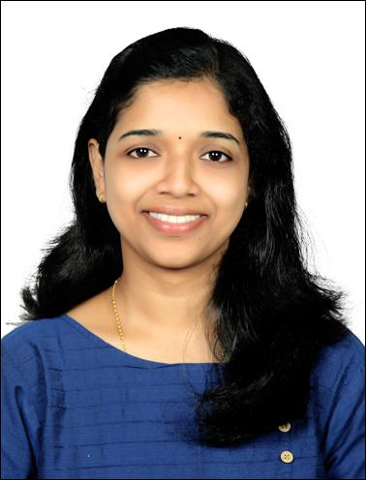
DESIGNATION | ASSISTANT PROFESSOR
QUALIFICATION | M.Sc. , NET
EMAIL ID | linumaryjo@gmail.com
PHONE NO | 9400639478

TEACHING INTERESTS

RESEARCH AREAS
OPTICS, SPECTROSCOPY

ACADEMIC/PROFESSIONAL QUALIFICATIONS*
NAME OF THE PROGRAMME | INSTITUTION/UNIVERSITY | YEAR OF PASSING
MSC PHYSICS | SACRED HEART COLLEGE CHALAKUDY | 2017
BSC PHYSICS | SACRED HEART COLLEGE CHALAKUDY | 2015
PLUS TWO | C K M N S S SENIOR SECONDARY SCHOOL CHALAKUDY | 2012
10TH | C K M N S S SENIOR SECONDARY SCHOOL CHALAKUDY | 2010

OTHER TRAINING PROGRAMS ATTENDED
NAME OF THE PROGRAMME | INSTITUTION/UNIVERSITY | YEAR

CAREER HISTORY/TEACHING EXPERIENCE
DESIGNATION | INSTITUTION/UNIVERSITY | YEAR OF SERVICE
ASSISTANT PROFESSOR (DD CONTRACT) | ST PAULS COLLEGE KALAMASSERY | 2024-2025
ASSISTANT PROFESSOR (DD CONTRACT) | AL AMEEN COLLEGE EDATHALA | 2023-2024
ASSISTANT PROFESSOR (DD CONTRACT) | ST TERESAS COLLEGE ERNAKULAM | 2019
ASSISTANT PROFESSOR(FDP) | ST TERESAS COLLEGE ERNAKULAM | 2017-2019

INDUSTRIAL EXPERIENCE
DESIGNATION | ORGANISATION | YEAR OF SERVICE
NIL

PHD THESIS
SL.NO | TITLE | GUIDE NAME | INSTITUTION | MONTH/YEAR
 | NIL

RESEARCH GUIDESHIP
-NA-

M.PHIL/PH.D GUIDED
SL.NO | NAME OF THE STUDENT | TITLE | UNIVERSITY &  WORK CENTRE | MONTH/  YEAR
 | -NA-

RESEARCH PROJECTS/GRANTS RECEIVED
SL.NO | TITLE | INVESTIGATORS | SPONSORING AGENCY | MONTH/YEAR
 | -NA-

AWARDS/ACHIEVEMENTS/OTHERS*
SL.NO. | NAME OF AWARDS/  ACHIEVEMENTS/OTHERS | DESCRIPTION | MONTH/  YEAR
*BEST PAPER,BEST POSTER,ANY OTHER POST HELD ETC…

JOURNAL PUBLICATIONS
SL.NO. | TITLE | NAME OF JOURNAL / VOL. NO / ISSUE NO / PAGE NOS | ISSN NO | MONTH /  YEAR
 | Active sites rich manganese doped MoS2 nanostructures with enhanced photodegradation of methylene blue dye | Journal of Alloys and Compounds  Volume 951, | 169856 | 5 August 2023,
 | Transparent heterojunctions of Cu-based delafossites n-CuInO2/p-CuGaO2 by reactive evaporation method for transparent electronic applications | Vacuum  Volume 197, , | 110808 | March 2022
CONFERENCE PUBLICATIONS

SL.NO. | TITLE | NAME OF CONFERENCE | VENUE,  MONTH /  YEAR

ARTICLES IN PERIODICALS/MAGAZINES/ANY OTHER
SL.NO. | TITLE | NAME OF PERIODICAL | MONTH/  YEAR
 | -NIL-

BLOG/WEB ARTICLES
SL.NO. | TITLE | URL | SUBJECT | MONTH /  YEAR

BOOKS AS AUTHOR/EDITED/CHAPTERS/REVIEWS
SL.NO | TITLE | AUTHOR NAMES | ISBN NO. | MONTH/  YEAR

ORIENTATION/REFRESHER COURSES ATTENDED
SL.NO | NAME OF THE PROGRAMME | NAME OF THE ORGANISER | MONTH/  YEAR

SEMINARS/CONFERENCES/WORKSHOPS ATTENDED#

SL.NO | NAME OF THE PROGRAMME | NAME OF THE ORGANISER&  SPONSORING AGENCY | VENUE &  DATE | LEVEL *
 |  |  |  | Regional
*INSTITUTIONAL, REGIONAL, STATE,NATIONAL, INTERNATIONAL
#(MENTION THOSE WHICH ARE RELEVANT & PREFERABLY WITHN PAST 5 YEARS)
SEMINARS ORGANIZED
SL.NO | NAME OF THE SEMINAR | NAME OF THE ORGANISER &  SPONSORING AGENCY | VENUE &  DATE | POSITION HELD | LEVEL *
*INSTITUTIONAL, REGIONAL, STATE,NATIONAL, INTERNATIONAL
PROFESSIONAL AFFILIATIONS/MEMBERSHIPS

INVITED TALKS/IN MEDIA/ANY OTHER

POSITIONS HELD IN COLLEGE

PG PROJECTS GUIDED

SL.NO | TITLE | MONTH/  YEAR

UG PROJECTS GUIDED
SL.NO | TITLE | MONTH/  YEAR

TRAINING PROGRAMS AND EXHIBITIONS

LECTURE NOTES

REFERENCES

