NAME | Kavya M Das | 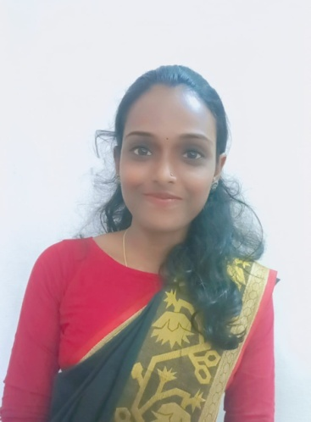
DESIGNATION | Assistant Professor on Contract
QUALIFICATION | M.Phil Marine Chemistry,  M.Sc Applied Chemistry
EMAIL ID | Kavyaajitha123@gmail.com
PHONE NO | 7560995090

TEACHING INTERESTS
Organic chemistry
Inorganic chemistry

ACADEMIC/PROFESSIONAL QUALIFICATIONS*
NAME OF THE PROGRAMME | INSTITUTION/UNIVERSITY | YEAR OF PASSING
M.Phil Marine Chemistry | Cochin University Of Science And Technology | 2018
M.Sc Applied Chemistry | Sree Sankara College,Kalady | 2016
B.Sc Model IIChemistry | Morning star College,Angamaly | 2014

CAREER HISTORY/TEACHING EXPERIENCE
DESIGNATION | INSTITUTION/UNIVERSITY | YEAR OF SERVICE
Guest Lecturer | Sree Sankara College, Kalady | 2

ORIENTATION/REFRESHER COURSES ATTENDED
SL.NO | NAME OF THE PROGRAMME | NAME OF THE ORGANISER | MONTH/  YEAR
 | NEP 2020 Orientation & Sensitization program | UGC- Malaviya Mission Teacher Training Centre,University of Calicut | 17/02/2025-26/02/2025

SEMINARS/CONFERENCES/WORKSHOPS ATTENDED#

SL.NO | NAME OF THE PROGRAMME | NAME OF THE ORGANISER&  SPONSORING AGENCY | VENUE &  DATE | LEVEL *
 | International Conference on Advances in Material Science | Sree Sankara College | Kalady  24th& 25th October 2018 | International
 | Sasthrayan | CUSAT | CUSAT  27th& 28th February 2018 | Regional
 | State level monthly Colloquim | Centre for Research, Extension and Studies in Literature and Arts,Sree Sankara College,Kalady | Kalady  30th January 2019 | State
*INSTITUTIONAL, REGIONAL, STATE,NATIONAL, INTERNATIONAL

REFERENCES
Dr. Sreekala M.S (AvH & JSPS Fellow)
Associate Professor, School of Chemical Sciences (SCS)
Director, School of Polymer Science and Technology (SPST)
Mob: 9446866088

